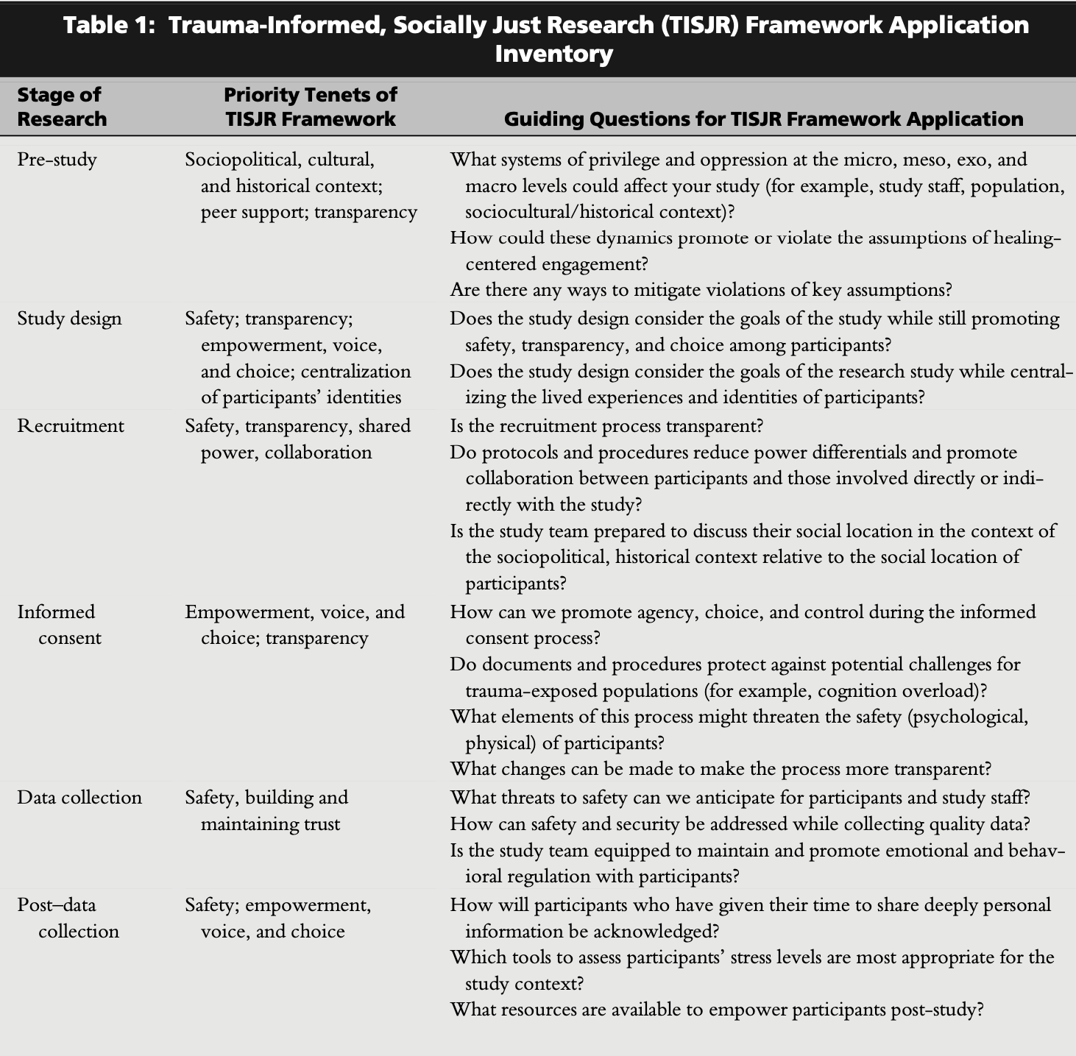
Source: Voith, L. A., Hamler, T., Francis, M. W., Lee, H., & Korsch-Williams, A. (2020). Using a trauma-informed, socially just research framework with marginalized populations: Practices and barriers to implementation. Social Work Research, 44(3), 169-181.

